**Signals**

**LAB # 11**



**Fall 2023**

**CSE-302L Systems Programming Lab**

Submitted by: **Ali Asghar**

Registration No.: **21PWCSE2059**

Class Section: **C**

“On my honor, as student of University of Engineering and Technology, I have neither given nor received unauthorized assistance on this academic work.”

Submitted to:

**Engr. Abdullah Hamid**

Date:

**1st February 2024**

**Department of Computer Systems Engineering**

**University of Engineering and Technology, Peshawar**

**Task 1:**

Implement wait ( ) function

a. By changing the default behavior of SIGCHLD (without using pause or sigsuspend or sigwait)

b. Using pause () function

c. Using signal suspend option

d. Using sigwait

**Part a:**

**Code:**

**Output:**

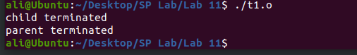

**Part b:**

**Code:**

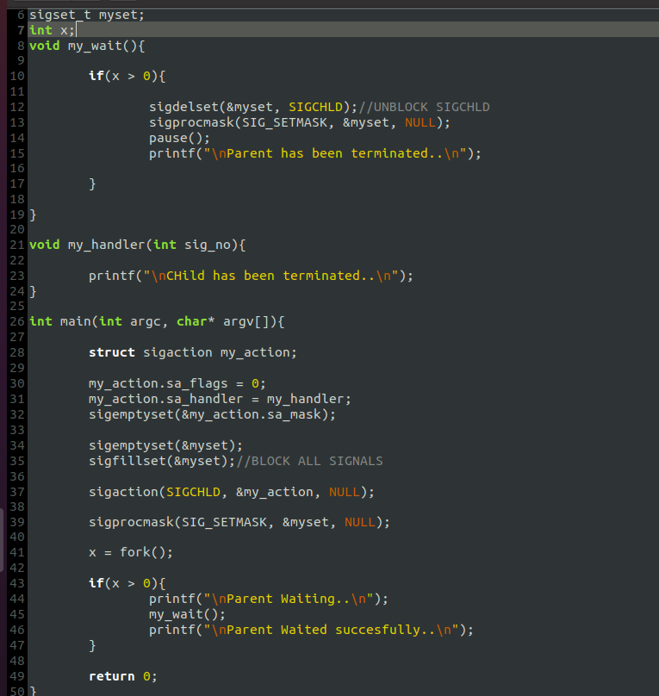

**Output:**

**Part c:**

**Code:**

**Output:**

**Part d:**

**Code:**

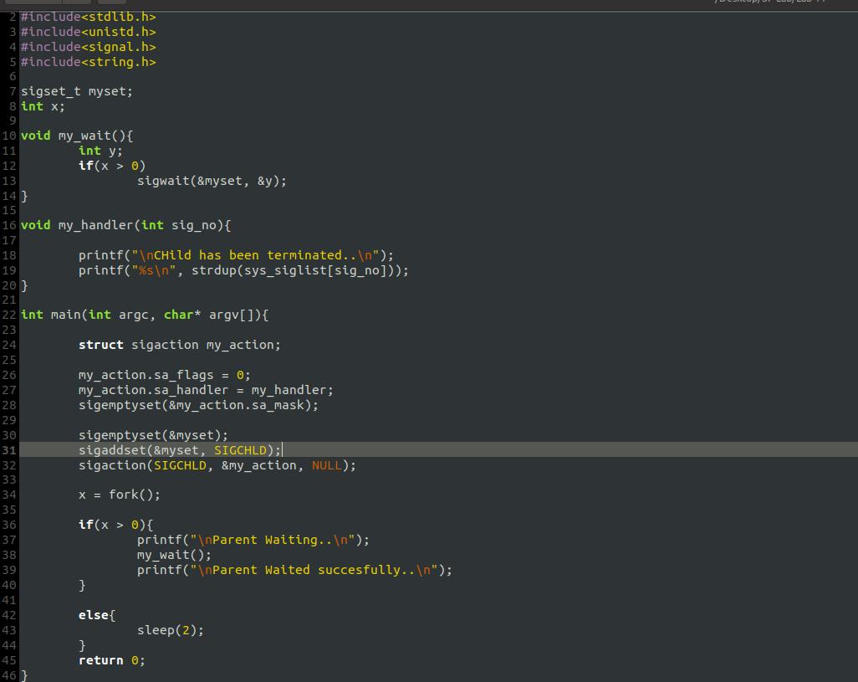

**Output:**

